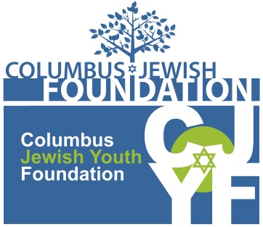

CJYF GRANTS HISTORY 2008-2016

2016
General Funding $5,000
- $1,000 Columbus Jewish Arts Center: Jewish Arts and Music Festival
- $2,000 LifeCare Alliance: IMPACT Safety On Your Own
- $2,000 OSU Hillel: Creating a Jewish Dorm Experience

Needs of Local Jewish Seniors $5,000
- $2,120 OSU Melton Center: Lecture Series at Creekside
- $2,880 Wexner Heritage Village: Refuah HaNefesh: Body, Mind, Soul Integrative Therapy

2015
Local Jewish Poverty $5,000
- $2,5oo Columbus Jewish Foundation: SCRIP for emergency temporary financial family needs
- $1,000 Jewish Family Services: Support for Survivors of Nazi Persecution
- $1,500 LifeCare Alliance: New Initiatives for the Kosher Food Program of Meals-on-Wheels

2014
Programs for People with Special Needs $5,000
- $2,ooo Jewish Federation of Columbus: Kesher Sundays Community Holiday Programming
- $1,080 Shalom House Inc.: Shalom House Shabbat
- $750 Chabad Friendship Circle: Gym & Dinner Night
- $1,170 Shalom House Inc. Koach Fund for Judaic Life and Learning - Special One Time Grant

2013
Youth: Jewish Identity or Israel Awareness $5,000
- $600 Columbus Jewish Day School: Feeds the Soul garden program
- $1,000 Jewish Federation of Columbus: PJ Library Shema Pillowcase Pajama Party
- $1,000 OSU Hillel: Ohio Loves Israel Annual Conference
- $2,400 Six-Synagogue Collaborative-Temple Israel: Israel Seminars High School Conference

2012
Enhanced Quality of Life $5,000
- $2,500 Jewish Community Center of Columbus: Shabbat in a Box
- $1,000 Jewish Experience for Teens: Culture Clubs Jewish Outreach in the Schools program
- $1,100 OSU Hillel: PB&Jam Campus-wide sandwich program
- $400 Zusman Hospice of WHV: Love and Hugs Memory Bear Program

2011
Hunger $5,000
- $500 Hadassah Columbus: Birthday Wishes Program for JFS and Homeless Families Foundation
- $2,064 OSU Hillel: PB&Jam Campus-wide sandwich program
- $1,000 JCC of Columbus Senior Emergency Meal Program
- $1,436 LifeCare Alliance: Kosher Meals on Wheels

2010
Local Jewish Day School Education $8,000
- $4,000 Columbus Jewish Day School: Environmental Education Programs
- $4,000 Columbus Torah Academy: Kindergarten Tuition Assistance

2009
General Funding $11,359
- $3,000 Columbus Jewish Federation: Camp Scholarship Program
- $2,484 OSU Hillel: Jr./Sr. Prom
- $2,875 Jewish Family Services: Healthy Dating Workshops
- $3,000 Wexner Heritage Village: Creative Arts Program

