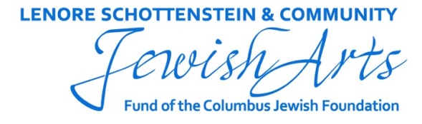

Program Evaluation for a Jewish Arts Grant

An evaluation, based on the approved grant amount and subject to any other special conditions listed in this section, must be submitted within 45 days of the end of the grant period or after the program has taken place, whichever comes first. The grant will close upon failure to submit the evaluation or to request a 30-day extension. Email WORD and EXCEL docs to Susan Tanur at stanur@tcjf.org and mail a copy along with supplemental material to Susan Tanur, Columbus Jewish Foundation, 1175 College Ave, Columbus, OH 43209. Adobe docs will not be accepted.

Refer to your grant proposal, grant agreement, or other subsequent correspondence when completing this evaluation.

Organization Name:
Grant Number:
Grant Project Title:
Grant Period:

- What were the program goals? To what extent did you achieve each goal?
- What outcomes did you see happen as a result of this grant? Were there any unexpected outcomes? If yes, please elaborate.
- What were the program successes? What were the program disappointments?
- What was the impact of the Foundation grant on this program?
- Evaluation Methodologies (add additional lines as needed)

List each evaluation methodology | Which groups participated; Total no. invited | Actual no. participants | Who evaluated the results | Key findings | Proposed changes based on key findings

Please add any additional evaluation comments here:

- Attendance Details (add additional lines as needed)

List each program | Targeted audiences | Audience capacity | No. adult attendees | No. attendees 18 or younger | Total attendees | Any surprises?

Please add any additional attendance comments here:
- How did you publicize the program? Which approaches yielded the greatest return?
- How did you make your program accessible to those who often are underserved by the arts (e.g. economically disadvantaged; hearing, visually or physically impaired; seniors, etc.)
- What steps did you have in place to ensure high artistic quality in your activities?
- If there were partner organizations, who were they and what were their roles?
- If there were additional conditions attached to this grant, what were they and how were they met?
- What changes will you make if you do this program again?
- Submit photographs, bulletins, articles relevant to this program.
- Complete and submit the grant evaluation budget on the Columbus Jewish Foundation website: www.columbusjewishfoundation.org.
- Use this space to provide any additional information you would like to share that was not addressed above.
- If you would like to offer any feedback on the Foundation grant process, please do so here.

Submitted by:

Title:

Date submitted electronically:

Date mailed (including publicity):

Phone no.

Email address:

T:\Foundation Files\Grants\FY17 Grant Process\Evaluation - JEWISH ARTS.docx

