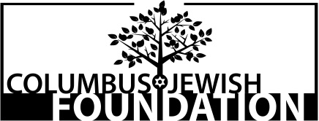

Program Update

Grantee:
Grant Number:
Grant Project Title:
Grant Period:

Questions:
- Is the program on schedule, moving faster than expected or running more than one month behind? Please explain.

- Since beginning the program, what have you learned about your original assessments of:
- The need for this program?

- The targeted population?

- Program design?

- Evaluation plan?

- Finances?

- Have you come across any challenges thus far? If so, how are they being addressed?

- If this project involved partnerships with other organizations, how is that working?

- If this project will continue, what steps have you taken to secure future funding?

- Complete and submit the program update budget on the Columbus Jewish Foundation website: www.columbusjewishfoundation.org.
- Submitted by:

Title:

Word and Excel docs emailed on:

Date mailed (including publicity):

Phone no.:

Email address:

T:\Foundation Files\Grants\FY19 Grant Process\FY19 Guide\Project Update.docx

